|  |  |
| --- | --- |
| ***2019 International Conference of Social Computing***  **Conference booklet** | sponsor  School of Social Sciences, Tsinghua University  organizer  Center for Network Research, Tsinghua University  Center for Big Data, Tsinghua University  supporting agency  Tsinghua University Press  Tencent Research Institute |

* **2019.8.26-8.27**
* **Jinchun Garden Third Conference Room, Tsinghua University**

**WELCOME**

This is the address of the conference venue

**Tsinghua University, Jinchun Garden Third Conference Room**

**Add: Shuangqing Road No.30 Tsinghua University**

**Haidian , Beijing 100872, China**

**Tel: 86-10-6279-3001**

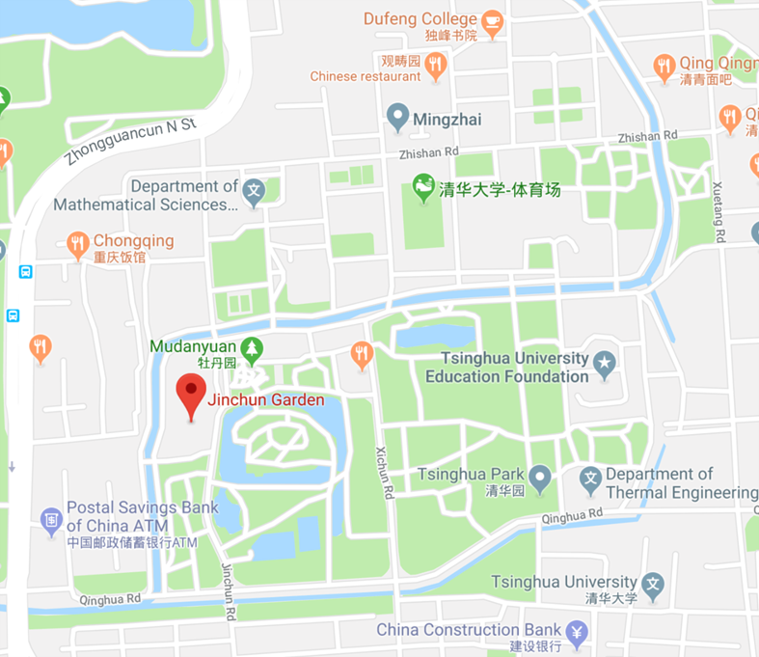

**2019 International Conference of Social Computing, Tsinghua University**

**Program**

|  |  |  |
| --- | --- | --- |
| **August 26**  **Research Presentation 1** | | |
| Exact Time | Presenter | Theme |
| 8:30-8:40 |  | Opening Speech |
| 8:40-9:05 | James A. Evans  Department of Sociology  The University of Chicago |  |
| 9:05-9:30 | Noshir Contractor  McCormick School of Engineering & Applied Science  Northwestern University |  |
| 9:30-9:55 | Irwin King  Department of Computer Science & Engineering,  The Chinese University of Hong Kong |  |
| 9:55-10:20 | Xiaoming Fu  Institute of Math and Computer Science  University of Gottingen |  |
| 10:20-10:35 | **Tea Break** | |
| 10:35-11:00 | Jarder Luo  Department of Sociology  Tsinghua University | Predicting Chinese Guanxi Circles by Using Social Network Data. |
| 11:00-11:25 | Zhiyuan Liu  Department of Computer Science  Tsinghua University |  |
| 11:25-11:50 | Tao Zhou  School of Computer Science  University of Electronic Science and Technology of China |  |
| 11:50-12:10 | Q & A | |
| 12:10-13:30 | **Lunch** | |
|  | | |
| **August 26**  **Research Presentation 2** | | |
| Exact Time | Presenter | Theme |
| 13:30-13:55 | Charles Edward Catlett  Department of Energy  Argonne National Laboratory | Understanding Urban Systems with Edge Computing and Coupled Computational Models |
| 13:55-14:20 | Robert West  Department of Epidemiology and Public Health  University College London |  |
| 14:20-14:45 | Ying Fan  School of System Science  Beijing Normal University |  |
| 14:45-15:10 | Yu-Sung Su  Department of Political Science  Tsinghua University |  |
| 15:10-15:25 | **Tea Break** | |
| 15:25-15:50 | Paolo Parigi  Institute for Research in the Social Sciences  Stanford University |  |
| 15:50-16:15 | Cristian Danescu-Niculescu-Mizil  Department of Information Science  Cornell University |  |
| 16:15-16:40 | Peter Krafft  Oxford Internet Institute  University of Oxford | Research and Action in Social Computing |
| 16:40-17:05 | Yang Chen  Department of Computer Science  Fudan University | Identifying Structural Hole Spanners in Online Social Networks Using Machine Learning |
| 17:05-17:30 | Q & A | |
| 18:00-20:00 | **Welcome Dinner** | |

|  |  |  |
| --- | --- | --- |
| **August 27**  **Research Presentation 3** | | |
| Exact Time | Presenter | Theme |
| 8:30-8:55 | Jiang Zhang  School of System Science  Beijing Normal University | Modelling Complex Systems --- Simple Rules v.s. Deep Learning |
| 8:55-9:20 | Christian Stegbauer  Department of Sociology  University of Frankfurt | Social Laws: Reducing Diversity in the Echo Chamber |
| 9:20-9:45 | Tianguang Meng  Department of Political Science  Tsinghua University |  |
| 9:45-10:10 | Alexander Mehler  Institute of Computer Science University of Frankfurt |  |
| 10:10-10:25 | **Tea Break** | |
| 10:25-10:50 | Ben Y. Zhao  Department of Computer Science  The University of Chicago | Data-driven Analysis of Social Computing Platforms and Behaviors, a Decade-long Retrospective |
| 10:50-11:15 | Xiaofeng Meng  School of Information  Renmin University of China |  |
| 11:15-11:40 | Yucheng Liang  Department of Sociology  Sun Yat-sen University |  |
| 11:40-12:05 | Krishna Gummadi  Max Planck Institute for Software Systems |  |
| 12:05-12:20 | Q & A | |
| 12:20-13:50 | **Lunch** | |

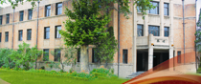

***ABOUT THE SCHOOL OF SOCIAL SCIENCE, TSINGHUA UNIVERSITY***

Since the establishment of the Tsinghua School (Xuetang) in 1911, courses in political science and economics were offered. In 1925, the school launched its four-year undergraduate program. The Departments of sociology, political science, economics and educational psychology were among the seventeen first founded departments in 1926. In 1928, the authorities officially changed the name to National Tsinghua University, and established fifteen departments in the School of Liberal Arts, the School of Science and the School of Law. The Department of Sociology was in the School of Liberal Arts; the Department of Psychology was in the School of Science; and the Departments of Political Science and Economics in the School of Law.

The study of social science at Tsinghua University has a long tradition of promoting interaction between Chinese and Western cultures and encouraging interdisciplinary communications between the Arts and the Sciences. Advocating for the application modern science methodologies in exploring political, economic and social phenomena, we learned from studies in foreign countries and followed international academic standards, with an emphasis on understanding current realistic problems in China. Founded on the ultimate goal to support the independent academic development of the nation and the construction of a new China, the school has made significant achievements in nurturing students and research.

Many world-class scholars and social activists taught or studied in Tsinghua’s social science departments, including Fei Xiaotong（Fei Hsiao-Tung）, Chen Daisun, Zhang Xiruo, Pan Guangdan, Qian Duansheng（Ch'ien Tuan-Sheng), Xiao Gongquan, Wang Tieya, Wang Yanan, Chen Da, Zhu Junyi, Wu Qiyuan, Zhao Yuanren（Chao Yuen Ren), Dai Shiguang, Xiao Qu, Wu Jingchao, Li Jinghan, Chen Tiqiang, and Tang Yue. They were pioneers of all Tsinghua faculties and students in social sciences disciplines who contributed to modern political and economical revival and social construction of China.

In 1952, a nationwide restructuring of institutes of higher education began, and Tsinghua University became a multidisciplinary polytechnic university specializing in training engineers. Social science departments in Tsinghua University were shut down and faculties and students in the field left for other universities or institutions. Since 1978, however, Tsinghua University has strengthened its teaching in the sciences, economic management, humanities and law fields. Resuscitating its studies and research in social science disciplines, the Department of Social Science was rebuilt in 1984 and School of Humanities and Social Sciences was rebuilt in 1993, which included the Department of Philosophy and Sociology, Department of Chinese Language and Literature, Department of History, the Institute of Ideology and Culture, the Institute of Science, Technology and Society, the Institute of Economics, the Institute of Education, and the Institute of Art Education. In 1997, the Institute of international studies was set up. In 2000, the Department of Sociology and Department of Political Science were re-established. Finally, in 2008, the Department of Psychology was re-established.

In 2012, the first year after the centenary anniversary of Tsinghua University, the School of Humanities and the School of Social Sciences were founded separately on the basis of the original School of Humanities and Social Sciences. The School of Social Sciences includes the Department of Political Science, Department of International Relations, Department of Sociology, Department of Psychology, Institute of Economics . The School aims to meet the academic frontiers of the world and the strategic demands of our nation, and tries its best to attain new achievements in social sciences at Tsinghua University.

**

***ABOUT THE CENTER FOR SOCIAL NETWORK RESEARCH***

The Tsinghua Center for Social Network Research was founded on Jan. 1st 2013. As a Tsinghua University research center, its purpose is to develop a platform for cooperation among physicists, computer scientists, and social, behavioral and epidemiology researchers, so that they can explore a set of interdisciplinary methodological approaches for studying complex social networks in big data.

Big data brings a lot of opportunities and challenges for interdisciplinary research: Various domains of knowledge have developed and accumulated a large body of hypotheses, models and empirical findings on the structure, dynamic processes, and consequences of social networks.

In order to arrive at a consensus we first need to create a methodological framework that takes data mining as its starting point. The object of research is online big data, which has the untapped potential to yield findings about new social phenomena. The next step is interpreting these findings through various qualitative and survey studies, which will further help us reveal grounded truth to verify theoretical hypotheses. The final step is building a model that encompasses the co-evolution of human actions and network structure based on the operative theories. With a model built on this solid foundation, researchers trained with interdisciplinary methods have the required information to predict new facts from their results.

Running in parallel to our research are real-world surveys that often generate new facts that conflict with our interpretation of the results of data mining. In this kind of scenario, we must return to our data and begin an iterative process of data mining, theory development and dynamic model building; until we can reconcile the two sets of results.

The goal of TCSNR is to develop a series of programs for training students with different research backgrounds, and mesh their different areas of expertise into a methodologically and substantively integrated whole. From this interdisciplinary training method we can expect new results and considerable progress in social network research.



***ABOUT THE INSTITUTE FOR DATA SCIENCE***

Tsinghua University Institute for Data Science，based on Tsinghua University,  aims to foster discipline integration and innovation, serve national strategies, promote industrial development, cultivate leading talents, lead first-class researches, and finally establish the most powerful team in China Big Data field.

Get more information：

www.ids.tsinghua.edu.cn



***ABOUT THE TSINGHUA UNIVERSITY PRESS***

The International Cooperation Department of Tsinghua University Press (TUP) specializes in the press’ overseas business development and copyright trade.

As one of the first Chinese publishing companies to work with overseas trade partners, TUP started its international cooperation in 1990s. Over the years, we have been actively involved in the international exchange and market competition. With the working philosophy of being "open, innovative, professional and efficient", the International Cooperation Department works not only as the press’ window to the outside world, but also a bridge connecting to the world.

Thanks to the rich resources of Tsinghua University, TUP has been highly active at the frontiers of Chinese academic and higher education publishing.

By introducing thousands of high quality overseas titles to the Chinese market, TUP has promoted the international exchange in education and culture on one hand, and established strategic partnerships with many famous international publishing companies such as Pearson Education, Elsevier, John Wiley & Sons, Springer, McGraw Hill Education, Taylor Francis, etc. on the other hand.

TUP is now an experienced publisher favored by many outstanding authors and translators whose works appeal to other publishing companies for they represent the most advanced level of academic research in China. Up till now, TUP has licensed hundreds of titles to publishers in the United States of America, Germany, the United Kingdom, France, Japan, Singapore, South Korea, etc.

With the arrival of the digital era, the International Cooperation Department will take a more open and positive attitude towards international publishing. We sincerely hope to develop a closer and more in-depth cooperation with partners around the world in areas like science and technology, medicine, humanities and social sciences, business and management, children's books, popular books, etc.

**List of Participants**

|  |  |
| --- | --- |
| Charles Edward Catlett | U.S. Department of Energy’s Argonne National Laboratory |
| Yang Chen | Fudan University |
| Yunsong Chen**\*** | Nanjing University |
| Noshir Contractor | Northwestern University |
| Cristian Danescu-Niculescu-Mizil | Cornell University |
| James A. Evans | The University of Chicago |
| Ying Fan | Beijing Normal University |
| Xiaoming Fu | University of Gottingen |
| Krishna Gummadi | Max Planck Institute for Software Systems |
| Irwin King | The Chinese University of Hong Kong |
| Peter Krafft | University of Oxford |
| Yucheng Liang | Sun Yat-sen University |
| Zhiyuan Liu | Tsinghua University |
| Jarder Luo | Tsinghua University |
| Alexander Mehler | University of Frankfurt |
| Tianguang Meng | Tsinghua University |
| Xiaofeng Meng | Renmin University of China |
| Paolo Parigi | Stanford University |
| Alex Sandy Pentland**\*** | Massachusetts Institute of Technology |
| Christian Stegbauer | University of Frankfurt |
| Yu-Sung Su | Tsinghua University |
| Jie Tang | Tsinghua University |
| Robert West | University College London |
| Jiang Zhang | Beijing Normal University |
| Ben Y. Zhao | The University of Chicago |
| Tao Zhou | University of Electronic Science and Technology of China |

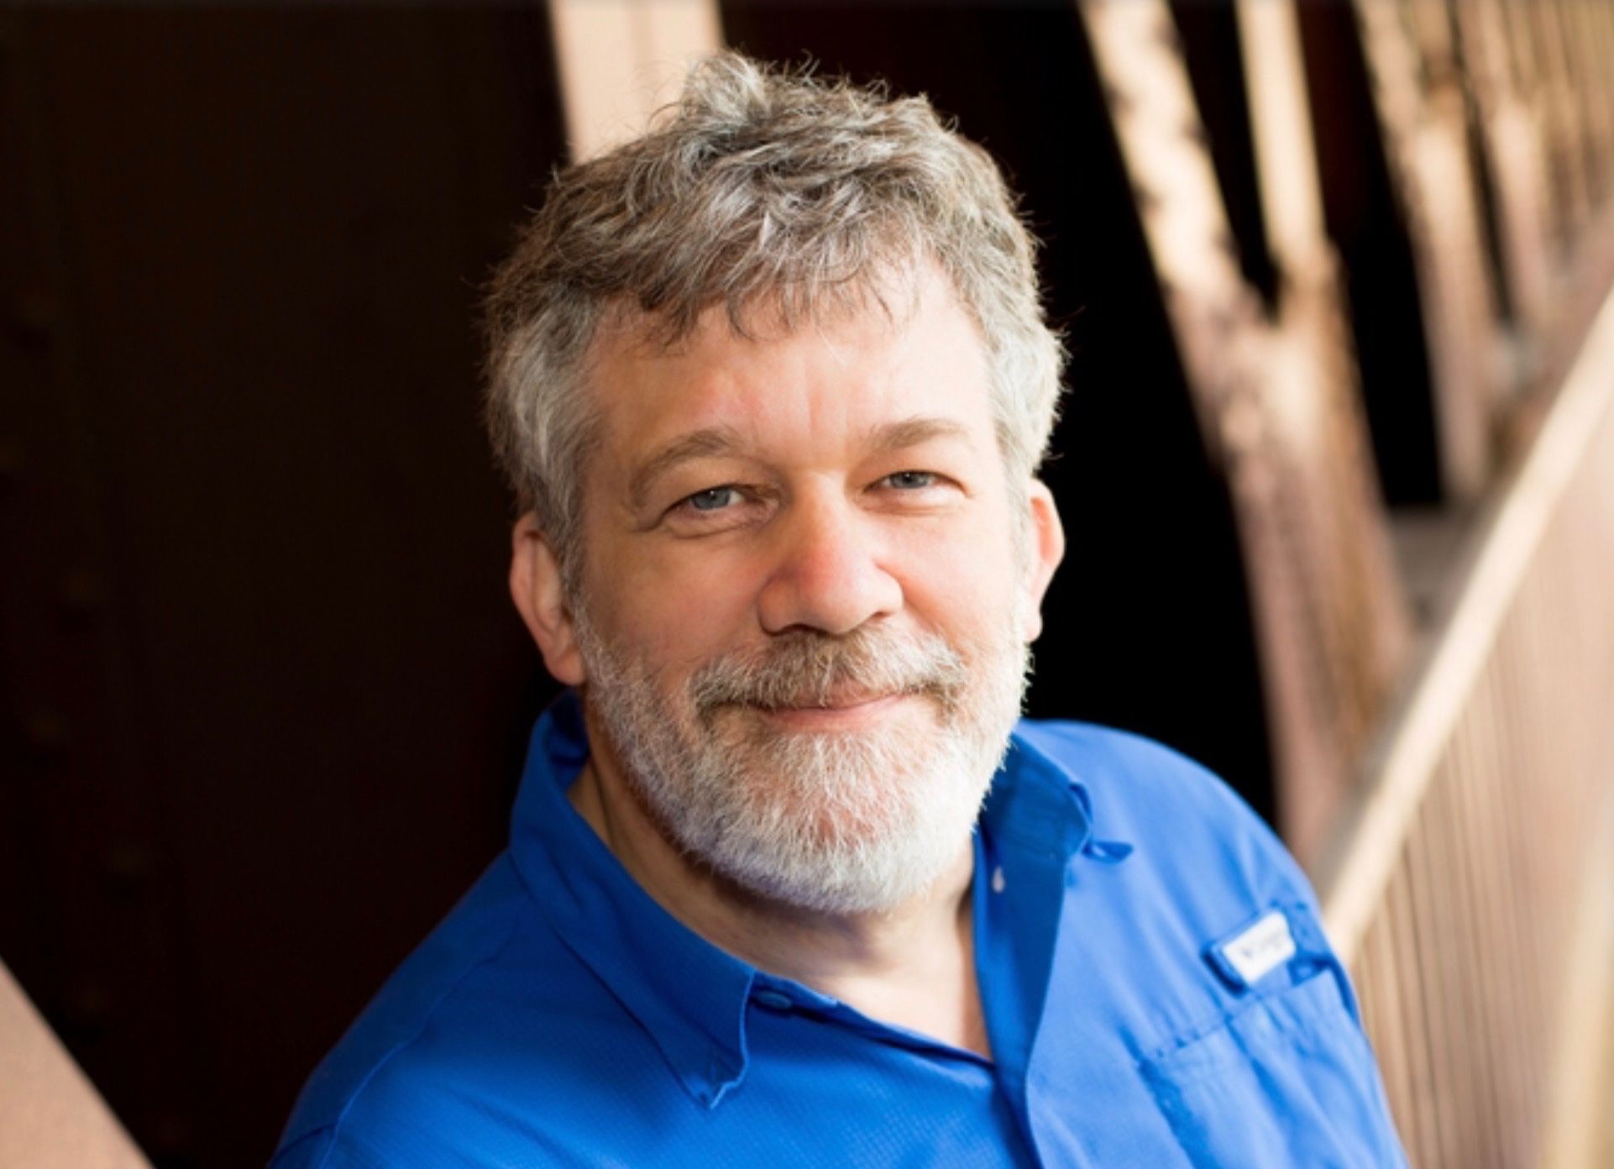 **Charles Edward Catlett**

Sr Computer Scientist

U.S. Department of Energy’s Argonne National Laboratory

Charles Catlett is a Senior Computer Scientist at the U.S. Department of Energy’s Argonne National Laboratory and a Senior Fellow at the University of Chicago’s Mansueto Institute for Urban Innovation. His current research focuses on urban data analytics, urban modeling, and the design and use of sensing and “edge” computing technologies embedded in urban infrastructure. He is the principal investigator of the NSF-funded “Array of Things” (AoT), an experimental urban infrastructure to measure the city’s environment with sensors and embedded (“edge”), remotely programmable artificial intelligence hardware. Operating at over 100 locations in Chicago, AoT is expanding to 200 during summer 2019.

Catlett has served as Argonne’s Chief Information Officer and before joining UChicago and Argonne in 2000, he was Chief Technology Officer at the National Center for Supercomputing Applications at the University of Illinois at Urbana-Champaign. From NCSA’s founding in 1985 he participated in the development of NSFNET, one of several early national networks that evolved into what we now experience as the Internet. During the exponential growth of the web following the release of NCSA’s Mosaic web browser, his team developed and supported NCSA’s scalable web server infrastructure.

Charlie founded the Urban Center for Computation and Data at the University of Chicago in 2012, was recognized as one of Chicago’s “Tech 50” technology leaders by Crain’s Chicago Business in 2014, and nationally as one of “25 Doers, Dreamers & Drivers” of 2016 by Government Technology magazine. He is a Computer Engineering graduate of the University of Illinois at Urbana-Champaign.

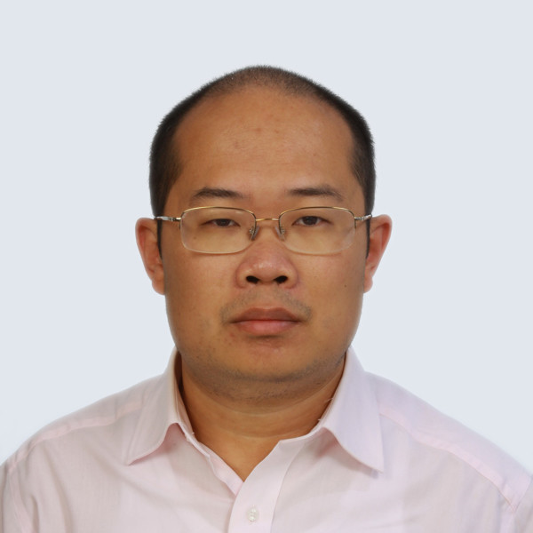 **Yang Chen**

Associate Professor

School of Computer Science

Fudan University

Yang Chen is an Associate Professor within the School of Computer Science at Fudan University. He received his B.S. and Ph.D. degrees from the Department of Electronic Engineering in Tsinghua University, in 2004 and 2009, respectively. He was a Postdoctoral Associate at the Department of Computer Science in Duke University, and was a Research Associate at the Institute of Computer Science of the University of Goettingen, Germany. His research interests include online social networks, Internet architecture and mobile computing. He is serving as an Editorial Board Member of the Transactions on Emerging Telecommunications Technologies (ETT) and IEEE Access. He served as an OC / TPC Member for several international conferences, including SOSP, WWW, IJCAI, AAAI, IWQoS and ICCCN. He published more than 60 referred papers in international journals and conferences, including IEEE TPDS, IEEE TMC, IEEE TSC, IEEE TNSM, IEEE TCSS, IEEE Communications Magazine, Middleware, INFOCOM, ICDCS, ICDE, CIKM, ACSAC and IWQoS.

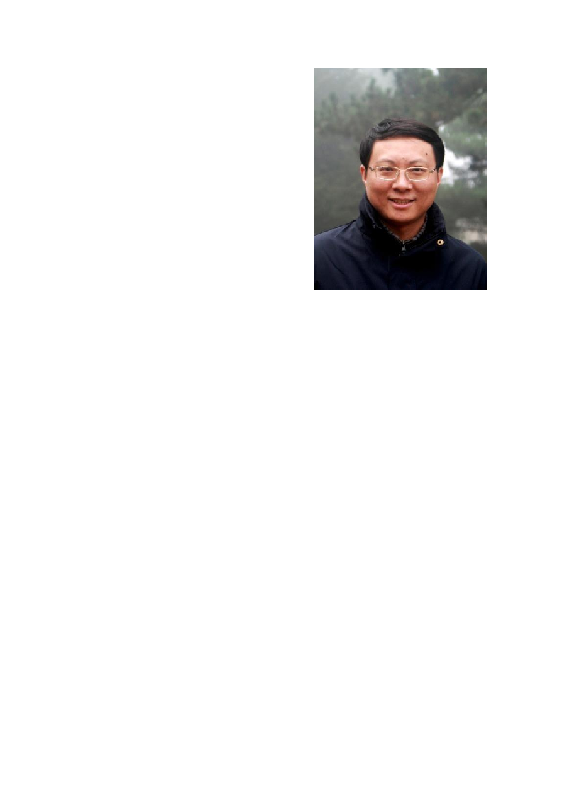 **Yunsong Chen**

Associate Professor

Department of Sociology

Nanjing University

Yunsong Chen is an Associate Professor of Sociology at Nanjing University; the Deputy Chief of Xuanwu District Government in Nanjing. Supported by the Clarendon Scholarship, he earned his D.Phil. in Sociology at Nuffield College, the University of Oxford in 2012. He has broad research interests within the fields of social networks and social relations. To date, his research includes empirically assessing the counterfactual causal effects of social networks in labor markets under different institutional contexts, using ‘big data’ to identify the long-term relationship between macro-level social- economic indicators and cultural phenomena, and subjective wellbeing and social status in China. His recent and forthcoming articles appear in leading English-language journals including Social Networks, Social Science Research, and British Journal of Sociology, as well as top Chinese journals including Social Science in China, Journal of Chinese Sociology and Chinese Journal of Sociology. In 2015 he was awarded various honors including the Distinguished Scholarly Publication Award by the Lu Xueyi Sociology Development Foundation, and the Fei Hsiao-Tung Scholarship for Distinguished Teachers.

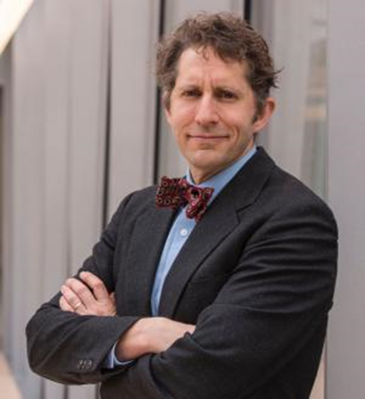  **James A. Evans**

Professor

Department of Sociology

The University of Chicago

My research focuses on the collective system of thinking and knowing, ranging from the distribution of attention and intuition, the origin of ideas and shared habits of reasoning to processes of agreement (and dispute), accumulation of certainty (and doubt), and the texture—novelty, ambiguity, topology—of understanding. I am especially interested in innovation—how new ideas and practices emerge—and the role that social and technical institutions (e.g., the Internet, markets, collaborations) play in collective cognition and discovery. Much of my work has focused on areas of modern science and technology, but I am also interested in other domains of knowledge—news, law, religion, gossip, hunches, machine and historical modes of thinking and knowing. I support the creation of novel observatories for human understanding and action through crowd sourcing, information extraction from text and images, and the use of distributed sensors (e.g., RFID tags, cell phones). I use machine learning, generative modeling, social and semantic network representations to explore knowledge processes, scale up interpretive and field-methods, and create alternatives to current discovery regimes. My research has been supported by the National Science Foundation, the National Institutes of Health, the Air Force office of Science Research, and many philanthropic sources, and has been published in Nature, Science, Proceedings of the National Academy of Science, American Journal of Sociology, American Sociological Review, Social Studies of Science, Research Policy, Critical Theory, Administrative Science Quarterly, and other outlets. My work has been featured in the Economist, Atlantic Monthly, Wired, NPR, BBC, El País, CNN, Le Monde, and many other outlets.

At Chicago, I am Director of Knowledge Lab, which has collaborative, granting and employment opportunities, as well as ongoing seminars. I also founded and now direct on the Computational Social Science program at Chicago, and sponsor an associated Computational Social Science workshop. I teach courses in augmented intelligence, the history of modern science, science studies, computational content analysis, and Internet and Society. Before Chicago, I received my doctorate in sociology from Stanford University, served as a research associate in the Negotiation, Organizations, and Markets group at Harvard Business School, started a private high school focused on project-based arts education, and completed a B. A. in Anthropology at Brigham Young University.

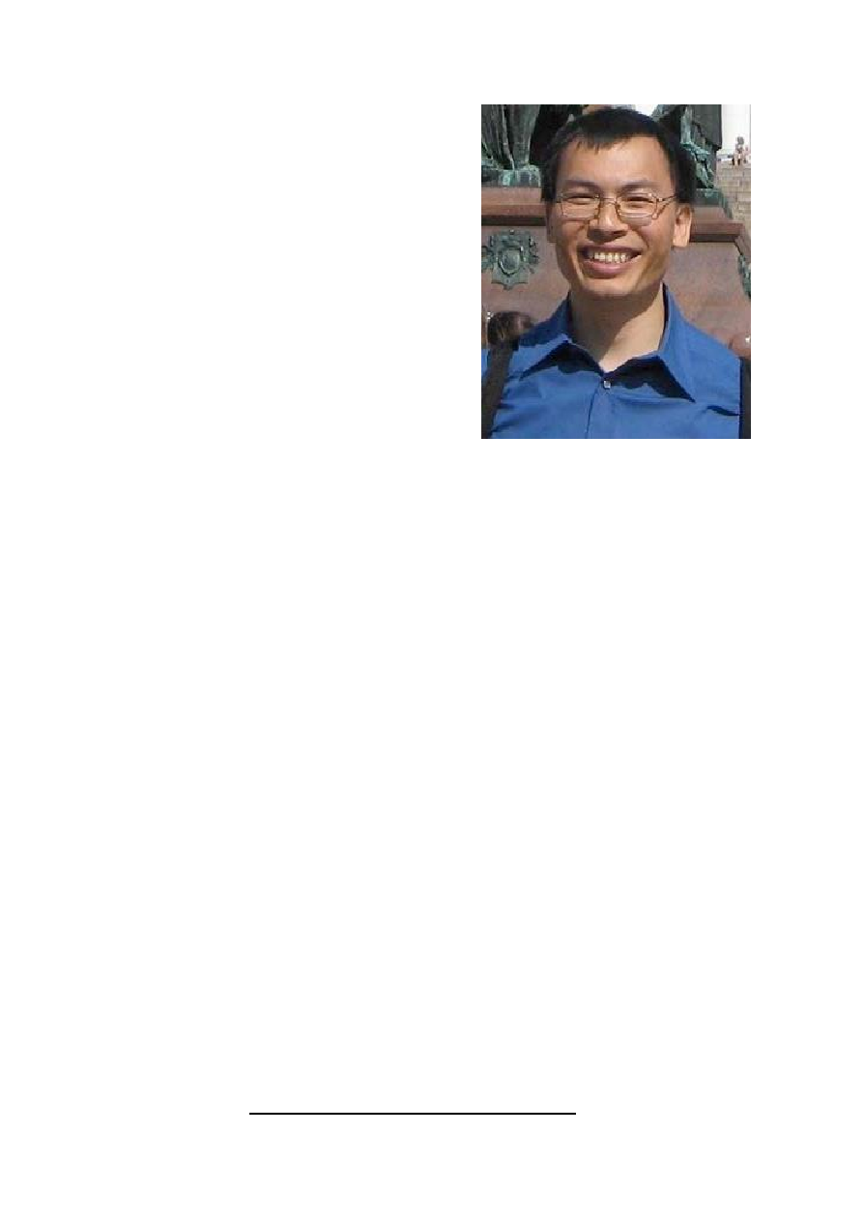 **Xiaoming Fu**

Professor

Institute of Computer Science

University of Gottingen

Xiaoming Fu received his Ph.D. degree in computer science from Tsinghua University, Beijing, China in 2000. He was then a research staff at the Technical University Berlin until joining the University of Gottingen, Germany in 2002, where he has been a professor in computer science and heading the Computer Networks Group since 2007. He has spent research visits at Cambridge, Columbia, UCLA, Tsinghua, Uppsala and UPMC, and is an IEEE senior member and Distinguished Lecturer.

Dr. Fu’s research interests include Internet-based systems, applications, and social networks. He is currently an editorial board member of IEEE Communications Magazine, IEEE Transactions on Network and Service Management, Elsevier Computer Networks, and Computer Communications, and has published over 150 peer-reviewed papers in renowned journals and international conference proceedings; more recently book co-edited by him, “Social Network Analysis: Inter disciplinary Approaches and Case Studies” will be published by CRC Press, Taylor & Francis Group in 2016. He has served on the program or organization committees of several networking conferences such as ACM MOBICOM, MOBIHOC, CoNEXT, COSN, IEEE NFOCOM, ICNP, ICDCS, ANCS, IWQoS, CCW, IFIP Networking and is currently general co-chair of ACM ICN’16 and program co-chair of ACMCFI’16 and IEEE/ACM/VDE NetSys’17. He is a founding steering committee member of ACM COSN, MobiArch and HotPlanet. He has served as secretary (2008-2010) and vice chair (2010-2012) of IEEE Communications Society Technical Committee on Computer Communications (TCCC), as well as chair (2011- 2013) of the Internet Technical Committee (ITC), a joint committee of the Internet Society and the IEEE Communications Society. He is currently the coordinator of three EU FP7 projects (Green ICN, Clean Sky and Mobile Cloud).

Dr. Fu is the recipient of the ACM ICN 2014 and IEEE LANMAN 2013 Best Paper Awards, and the 2005 University of Gottingen Foundation Award for Exceptional Publications by Young Scholars.

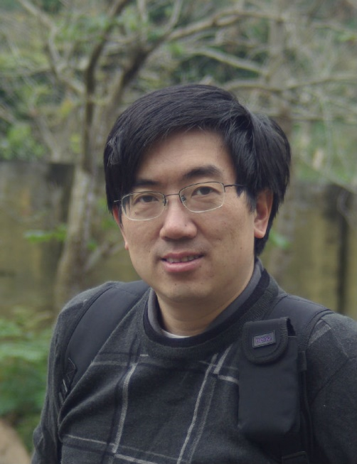 **Jar-Der Luo**

Professor

School of Social Sciences & School of Public Policy and Management

Chairman of Tsinghua Social Network Research Center

Tsinghua University

Luo Jar-Der is a professor of Sociology Dept., Tsinghua University in Beijing, president of Chinese Network for Social Network Studies, and chairman of Tsinghua Social Network Research Center. He earned his Ph.D. degree in Sociology Dept. of State U. of New York at Stony Brook. He researches numerous topics in social network studies, including social capital, trust, social network analysis in big data, self-organization process and Chinese indigenous management researches, such as guanxi and guanxi circle.

Luo Jar-Der, with a group of voluntary network theorists, organized Chinese Network for Social Network Studies (in brief, CNSNS) in 2005. Its purposes aim at promoting Network Theories and Social Network Analysis in China and developing network theories suited for Chinese management. Chinese always describe themselves as a “Ren-Ching society”, that is, roughly saying, a society built upon social ties (guanxi) and favor exchanges (Ren-Ching- jiau-huan).

Luo Jar-Der organized Community Revitalization Research Center in Tsinghua U., which aims at doing experiments in communities and establishing a model for sustainable revitalization in urban and rural areas that emphasizes sustainability of the local ecology, economy, and social systems. We make effort to implement a revitalization model combining private-public partnership and sustainable concepts into practice, incorporating scientific planning, balanced development, step-by-step implementation and self-reliance of local community into our plan.

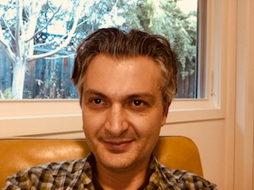 **Paolo Parigi**

Assistant Professor

Institute for Research in the Social Sciences

Stanford University

Paolo has spent the last few years studying trust interactions in the online markets of the sharing economy. He has conducted research on trust as an assistant professor at Stanford and as a research scientist first at Uber and then at Airbnb. In 2013, Paolo and Karen Cook received a NSF grant to support this line of work and since then their work has appeared on major academic journals. The nature of this work locates Paolo at the intersection of social sciences and computer science, in the emerging area of computational social science.

Paolo interests extends beyond online trust interactions and cover the broader area of the impact of technology on relationships. The key insight of his work is that technology is not only accumulating data but is transforming our social lives. As a result, there is now a space for an applied social science aimed at testing the mechanisms of social behavior through experimentation. Paolo’s current position in industry allows him to pursue this more applied side of computational social science.

Paolo has a MA in Quantitative Methods and a PhD in Sociology both from Columbia University. Since 2017, he has worked as Lead Trust Scientist at Airbnb in San Francisco.

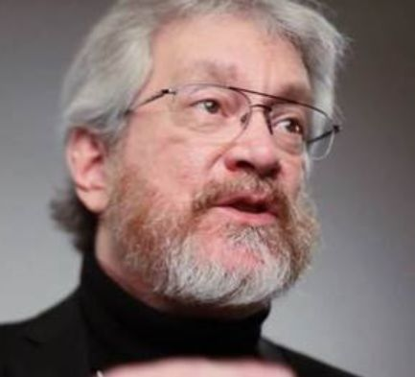  **Alex Sandy Pentland**

Professor

The MIT Media Lab

Professor Alex 'Sandy' Pentland directs the MIT Connection Science and Human Dynamics labs and previously helped create and direct the MIT Media Lab and the Media Lab Asia in India. He is one of the most-cited scientists in the world, and Forbes recently declared him one of the "7 most powerful data scientists in the world" along with Google founders and the Chief Technical Officer of the United States. co-led the World Economic Forum discussion in Davos that led to the EU privacy regulation GDPR, and was central in forging the transparency and accountability mechanisms in the UN's Sustainable Development Goals. He has received numerous awards and prizes such as the McKinsey Award from Harvard Business Review, the 40th Anniversary of the Internet from DARPA, and the Brandeis Award for work in privacy.

He is a founding member of advisory boards for Google, AT&T, Nissan, and the UN Secretary General, a serial entrepreneur who has co-founded more than a dozen companies including social enterprises such as the Data Transparency Lab and the Harvard-ODI-MIT DataPop Alliance . He is a member of the U.S. National Academy of Engineering and leader within the World Economic Forum.

Over the years Sandy has advised more than 60 PhD students. Almost half are now tenured faculty at leading institutions, with another one-quarter leading industry research groups and a final quarter founders of their own companies. Together Sandy and his students have pioneered computational social science, organizational engineering, wearable computing (Google Glass), image understanding, and modern biometrics. His most recent books are Social Physics, published by Penguin Press, and Honest Signals, published by MIT Press.

 **Christian Stegbauer**,

Professor

Department of sociology,

Johann Wolfgang Goethe-University Frankfurt am Main

Dr. Stegbauer is a professor in department of sociology, Johann Wolfgang Goethe-University Frankfurt am Main.

Dr. Stegbauer is Cofounder of the Online-Journal “kommunikation@gesellschaft”, Cofounder of the section for “Sociological Network Research” in the German Society of Sociology and also Cofounder and Chairperson of the German Society of Network Research. Fields of work are sociology of the internet, network research, sociology of culture and economic sociology.

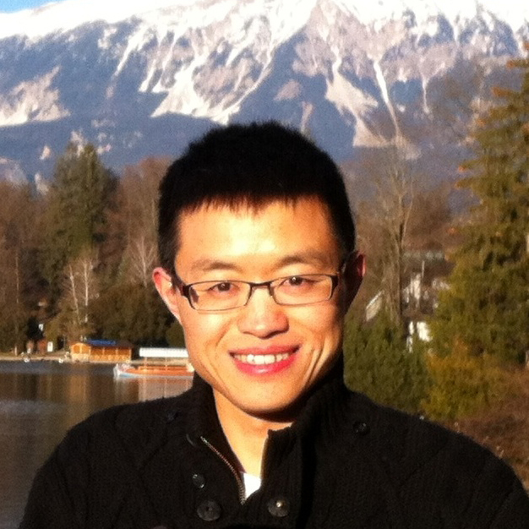  **Jie Tang**

Associate Professor

Department of Computer Science and Technology

Tsinghua University

Professor Tang’s interests include social network analysis, data mining, and machine learning. He has published more than 200 journal/conference papers and holds 20 patents. His papers have been cited more than 6,000 times (Google Scholar). He has been a visiting scholar at Cornell University, served as PC Co-Chair of CIKM’16, WSDM’15, ASONAM’ 15, Soclnfo’12, KDD-CUP/Poster/Workshop/ Local/Publication Co-Chair of KDD’11-15, and Associate Editor-in-Chief of ACM TKDD, Editors of IEEE TKDE/TBD and ACM TIST. He leads the project AMiner.org for academic social network analysis and mining, which has attracted more than 8 million independent IP accesses from 220 countries/ regions in the world. He was honored with the Newton Advanced Scholarship Award, CCF Young Scientist Award, and NSFC Excellent Young Scholar

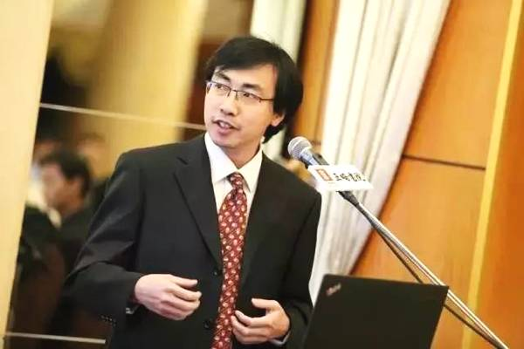 **Jiang Zhang**

Professor

School of Systems Science

Beijing Normal University

Dr. Jiang Zhang is a professor in School of Systems Science, Beijing Normal University and the founder of Swarma Club and Swarma Campus (Beijing) Science and Technology Lt. Co. He also provides consulting services for Tencent Research Institute. His major research interests include machine learning on graphs, scaling theory of cities and firms, etc. His works are published on international journals including Nature Communications, Scientific Reports, Physical Review E, and Journal of Theoretical Biology, etc. He is enthusiastic in teaching and science propagation for public. He teaches several popular courses in BNU, such as Complexity thinking, Artificial Intelligence, and MATLAB. He initiated Swarma Club in 2003, which is a well-known non-profit organization for inter-disciplinary scientific research in China. The club has stimulated some innovative ideas and even incubated startup AI teams (Colorful Cloud AI). Several academic papers are published on top journals like Nature, Nature Communications, Scientific Reports and so forth by the core members of Swarma Club. They also authored some popular science books for citizens, including The ultimate in science – Talking about Artificial Intelligence, Approaching 2050 – about Attention, Internet, and Artificial Intelligence, Deep Thinking(Translation), and Principles of Deep Learning and Practice for PyTorch.

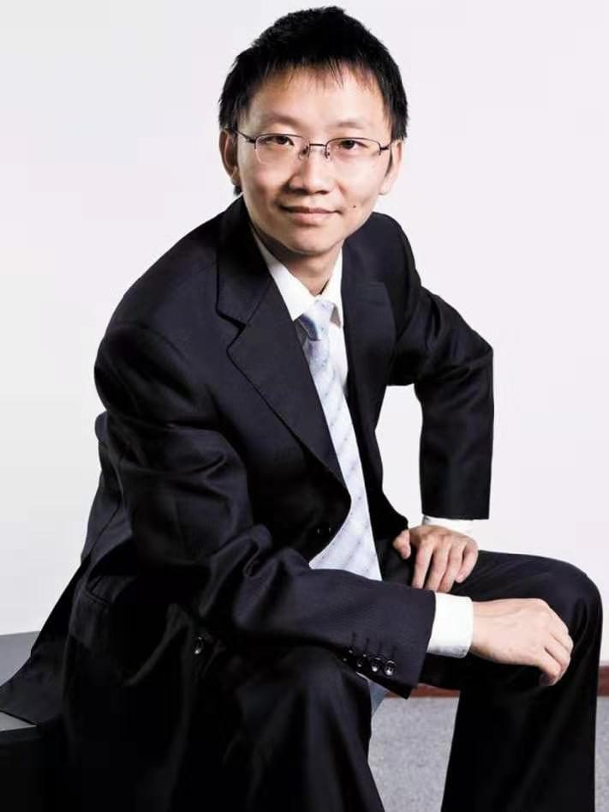 **Tao Zhou**

Professor

School of Computer Science

University of Electronic Science and Technology of China

Tao Zhou, a full professor in University of Electronic Science and Technology of China, who is mainly interested in statistical physics and complexity sciences. He has published 300+ papers in prestigious journals like Physics Reports, PNAS, Nature Communications and PRL. All his publications have received more than 22000 citations, with H-index being 70.